Lesson 15 – Activity Sheet

Getting Started

There are many different types of electrical and electronic components, including resistors, capacitors and LEDs. Each of these has a specific use in a circuit.

We will need to use these components when designing our vehicle’s nervous system and how it will interact with the outside world (the Human Computer Interaction)

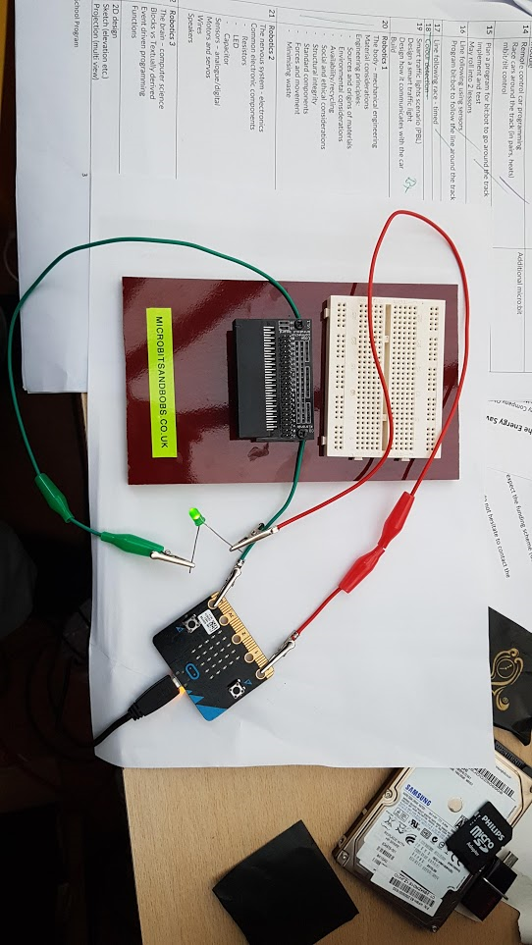***Connect a micro:bit directly to an LED and demonstrate how this can be turned on and off add two or three LEDs to different pins to turn them on/off in a sequence***

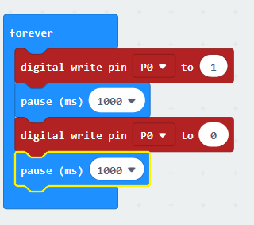

***Connect a micro:bit directly to a set of headphones and demonstrate how sound can be produced***

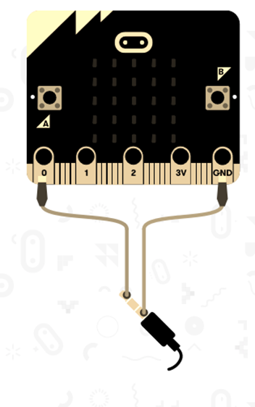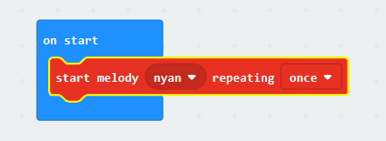

Success Criteria

* Understand the function of basic electronic components
* Use a micro:bit to control motors and servos
* Use a micro:bit to control the output from a speaker

Pro-tip

* Don’t rely on the simulator to test, it never sounds the same as through the speakers
* Think about how you can use rests between notes to stop the sound merging

Test Time

* How can you control more than one LED separately?
* How can you create unique sounds rather than just built in melodies?
* What happens if you use these features on the Bit:Bot?

Stretch Tasks

* How could you use the sound effects in your race car or circuit?
* What other components would you need to make this happen?
* Why doesn’t the onboard buzzer play sound in the same way?

Final Thoughts

* In today’s lesson we have looked at different electronic components and their uses. We have experimented with servos, motors, LEDS and sound on the micro:bit and considered how we could apply this to our race car and track